Parish Open Spaces & Asset Management

Public Consultation Questionnaire

Your Parish Council are undertaking a review of the management and maintenance plans for the open spaces in the parish.

These spaces are extensive and are listed below:
1. THE LAWNS RECREATION GROUND
2. LAND OFF THE DRIVE (adjacent to The Lawns)
3. THE VILLAGE GREEN
4. RADWAY STREET GARDEN
5. WALLIS GROVE GARDEN
6. BISHOPS AVENUE CAR PARKS
7. THE LAWNS MULTI USE GAMES AREA
8. THE LAWNS PLAY AREA
9. COCKHAVEN CLOSE PLAY AREA
10. ST JOHN'S CLOSED CHURCHYARD
11. THE PARISH CEMETERY
12. THE WAR MEMORIAL
13. PARISH BENCHES AND PICNIC SEATS
14. PUBLIC RIGHTS OF WAY

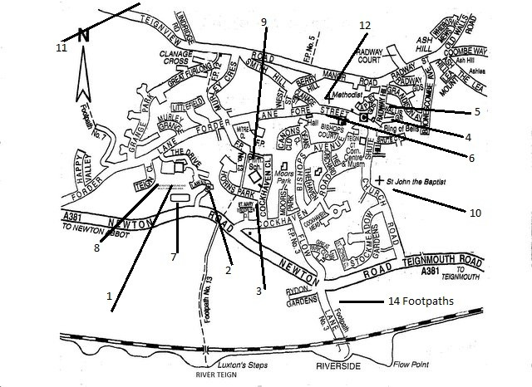

In order to provide the most relevant plan for management and maintenance of all open spaces and assets in the parish, we would ask you to take a few minutes to let us have your views and aspirations for the sites that we currently keep and preserve for the benefit of our community.

The Council have received an extended Phase 1 Habitat Survey which serves as a backing and information document for our deliberations. This and other documents are available for inspection on the website www.bishopsteignton-pc.gov.uk; also available at the Parish Council Offices, The Community Centre, Shute Hill, by appointment with the Clerk, Mrs. Kim Ford Tel: 01626 870170 0n Tuesday and Thursday mornings 10-12.

Some of the questions ask whether you would like to get involved and help with the planning and works on the sites. If you would, please give your permission to contact you on the details you have provided below.

When giving answers to some of the questions we ask you to rate the sites:-

1 - Excellent. 2 – Good. 3 – Average. 4 – Poor. 5 – Inadequate.

Your details
Name
Address
Telephone
email
Your personal information will be protected and treated in accordance with our privacy policy.
See https://www.bishopsteignton-pc.gov.uk/privacy-policy/
You will only be contacted if you give us your permission to do so.

Some general questions
Over the past 12 months how often have you visited any of our open spaces? | Once a week or more often
 | 3-4 times per month
 | 1-2 times per month
 | Once every two to three months
 | Once or twice per year
 | Less often
 | Never
How far is your home from your nearest open space? | Less than 5 minute walk
 | Within 5 – 10 minute walk
 | Within 10-20 minute walk
 | Over 20 minutes
On a scale of 1 -5 how much do you agree with the following statements about Greenspaces within the Parish:- | They should be where you can relax
 | They should be places to meet others from the community
 | They should encourage physical activity
 | They should be attractive
 | They should be safe spaces for children to play
 | They should provide an opportunity to see nature
I would like to have more of a say into how my local green space is managed
Please tick box to give permission to be contacted on the details you have provided

I would like to get involved in activities to help improve my local greenspace
Please tick box to give permission to be contacted on the details you have provided

On a scale of 1 - 5 how satisfied are you with your open spaces?
How important do you consider open spaces are?
Overall do you think your local spaces meet your needs?

And now some specific questions
The Lawns Recreation Ground (1):
How often do you visit this site
On a scale of 1 - 5 how would you rate the quality?
What do you like least?
What do you like most?

What improvement would you like to see made?

Land off The Drive, adjacent to The Lawns
This is a small area currently overgrown that stand just to the north of Stone Lodge and south of the electricity sub-station. It is currently unused.

Do you have any suggestions what this site could be used for?
What improvements, if any would you like to see made to this area?

The Village Green (3):
How often do you use this site?
On a scale of 1 - 5 how would you rate the quality?
What do you like least?
What do you like most?
What improvements would you like to see made?

Radway Street Gardens (4):
How often do you visit this site?
On a scale of 1 - 5 how would you rate the quality?
What do you like least?
What do you like most?
What improvements would you like to see made?

Wallis Grove Gardens (5):
How often do you visit this site?
On a scale of 1 - 5 how would you rate the quality?
What do you like least?
What do you like most?
What improvements would you like to see made?

Bishops Avenue Car Parks (6):
How often do you visit this site?
On a scale of 1 - 5 how would you rate the quality?
What do you like least?
What do you like most?
What improvements would you like to see made?

The Lawns Multi Use Games Area (7):
How often do you visit this site?
On a scale of 1- 5 how would you rate the quality?
What do you like least?
What do you like most?
What improvements would you like to see made?

The Lawns Play Area (8):
How often do you use this site?
On a scale of 1 - 5 how would you rate the quality?
What do you like least?
What do you like most?
What improvements would you like to see made?

Cockhaven Close Play Area (9):
How often do you visit this site?
On a scale of 1 - 5 how would you rate the quality?
What do you like least?
What do you like most?
What improvements would you like to see made?

St John’s Closed Churchyard (10):
How often do you visit this site?
On a scale of 1 - 5 how would you rate the quality?
What do you like least?
What do you like most?
What improvements would you like to see made?

The Parish Cemetery (11):
How often do you visit this site?
On a scale of 1 - 5 how would you rate the quality?
What do you like least?
What do you like most?
What improvements would you like to see made?

The War Memorial (12):
How often do you visit this site?
On a scale of 1 - 5 how would you rate the quality?
What do you like least?
What do you like most?
What improvements would you like to see made?

Parish benches and picnic seats
How often do you visit these sites?
On a scale of 1 - 5 how would you rate the quality?
What do you like least?
What do you like most?
What improvements would you like to see made?

Public Rights of Way
How often do you visit these paths?
On a scale of 1 - 5 how would you rate the quality?
What do you like least?
What do you like most?
What improvements would you like to see made?

Thank you for completing this survey. This information can help you check that we are on the right track from the most important point of view – that of you, the actual user.

Please return to the Bishopsteignton Parish Council Office at the Community Centre, Shute Hill, Bishopsteignton, TQ14 9QL.
Alternatively, there is an electronic version on the parish Council Website at www.bishopsteignton-pc.gov.uk/parish-assets/ which can be completed in Word and emailed to clerk@bishopsteignton-pc.gov.uk

Please return by Friday 2nd November 2018

